Exercise 6: Node and Express (P1)

Objective
In this exercise, you'll learn how to demonstrates a basic example of using Express Router to organize your routes. For larger applications, consider separating your routers into different modules or files.

Requirements
- Node.js is installed on your machine.
- Basic knowledge of Express framework.

Exercise 1:

Step 1: Prepare the Data File
Create a new file named data.json in your project directory with the following sample content:
{
"message": "Hello, world!"
}

Step 2: Build the Server
- Using the provided source code above, create a new file named server.js.
- Ensure you understand how the code works: how it reads from data.json and how to update data in this file.

Step 3: Practice and Extend
- Read Data:
Run the server and use a browser or Postman to send a GET request to the ‘/data’ endpoint. Check if you receive the data from data.json.
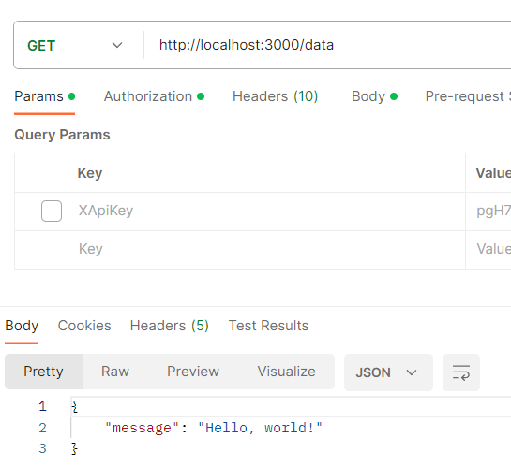
- Update Data:
Use Postman to send a POST request to the ‘/update’ endpoint with a new JSON object in the body. For example:
{
"message": "Updating with a new message!"
}

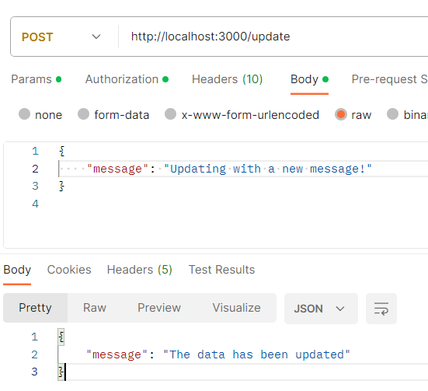
Send another GET request to /data to check if the data has been updated.

Exercise 2: From articles in db.json file, you’ll create all router for a subset of your application (GET/POST/PUT/DELETE)
- Create folder namely node-express
- Init NodeJS project with express framework
- Create all router for a subset of your application (GET/POST/PUT/DELETE) in app.js file as images below
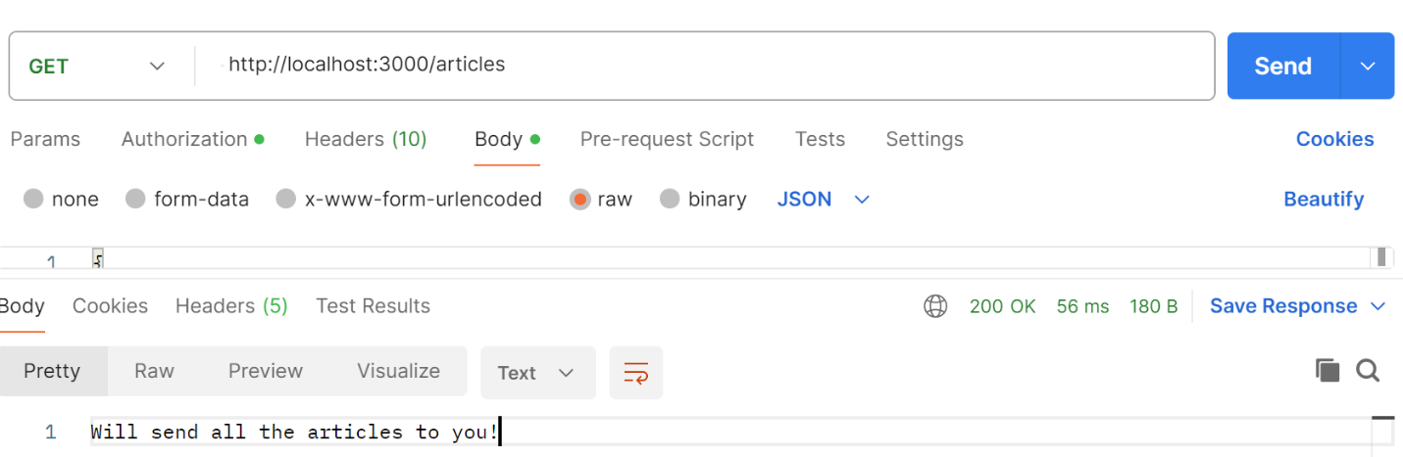
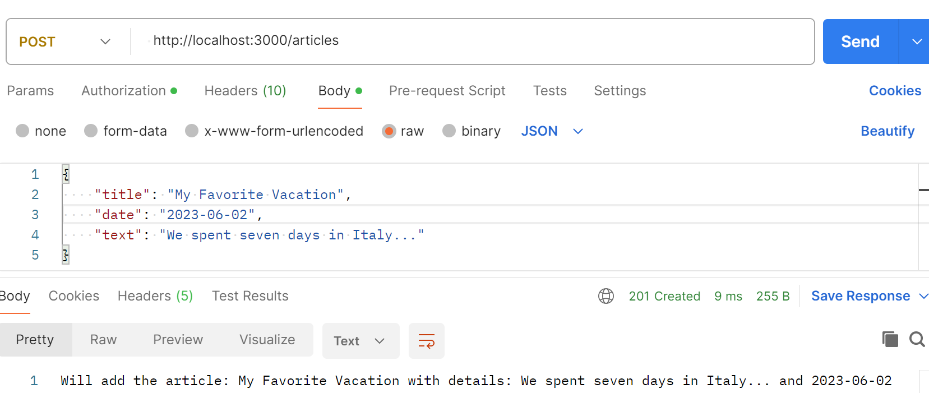
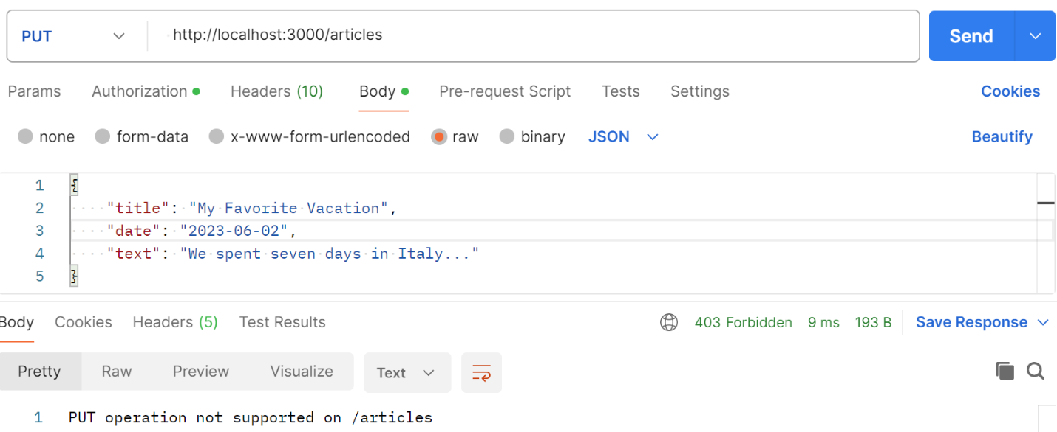

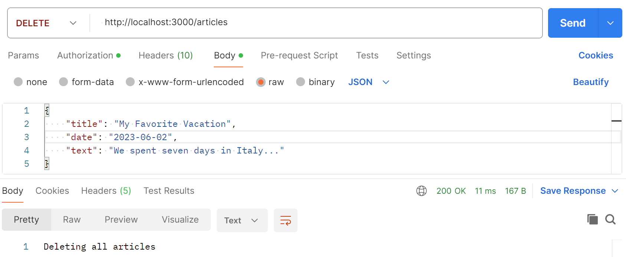

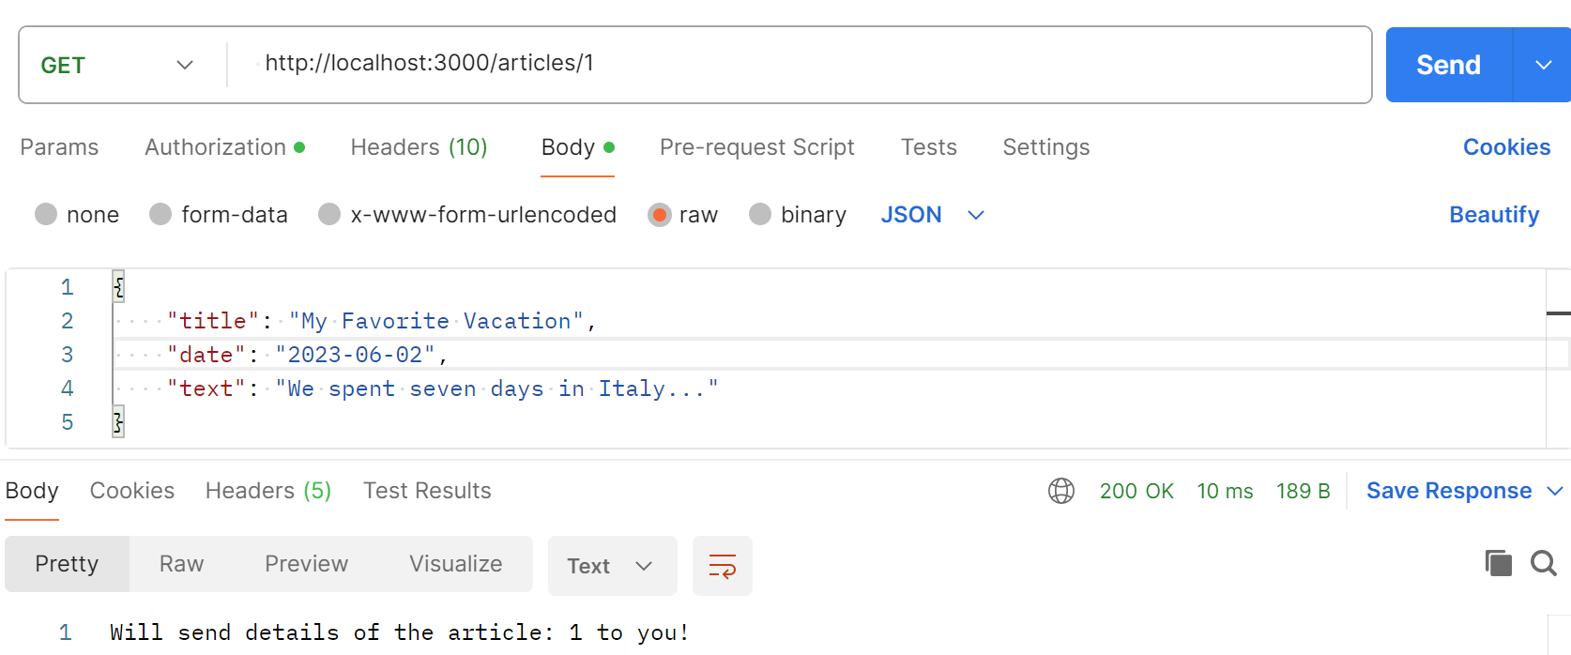

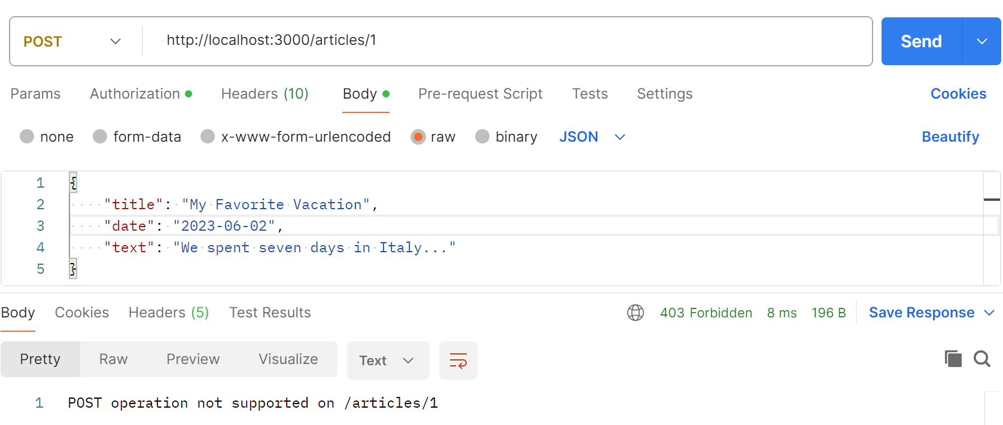

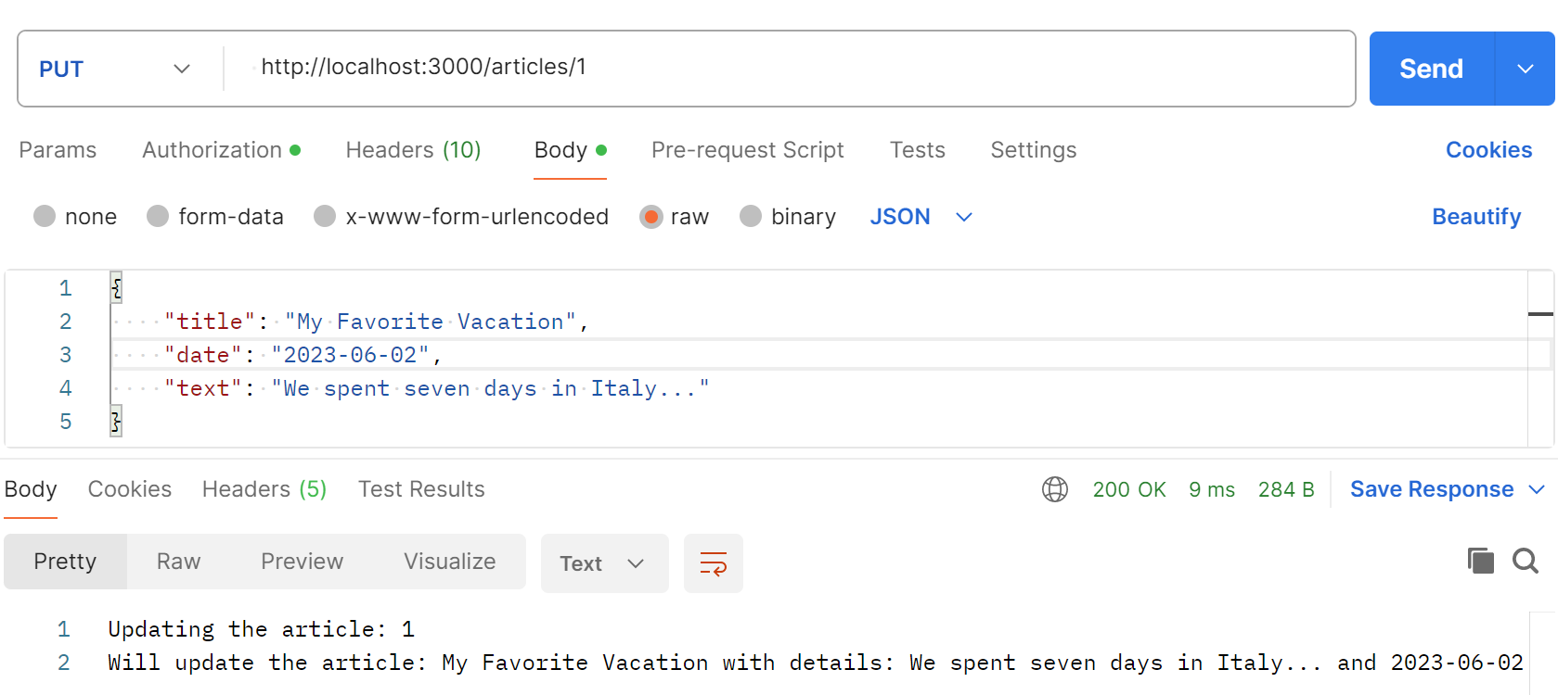

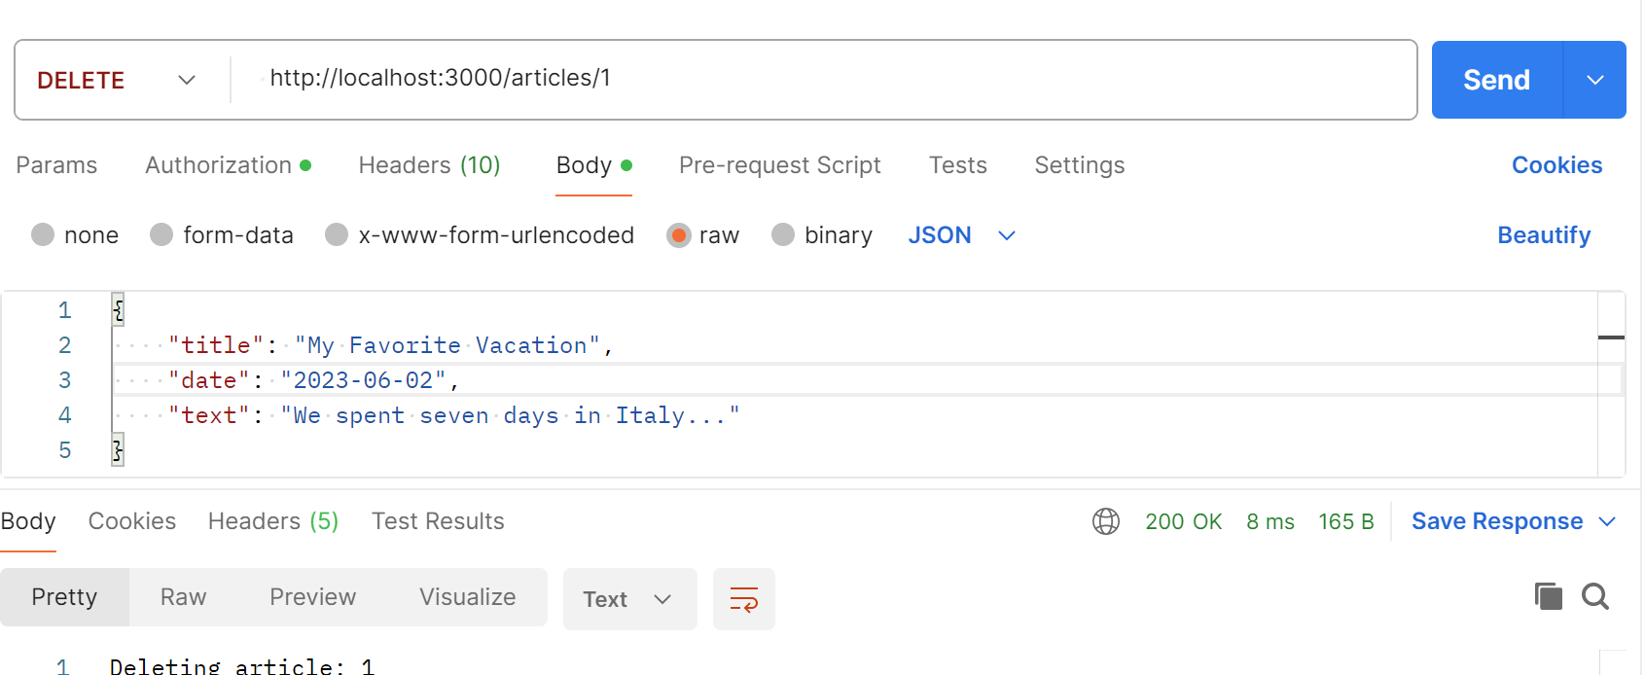
Hint

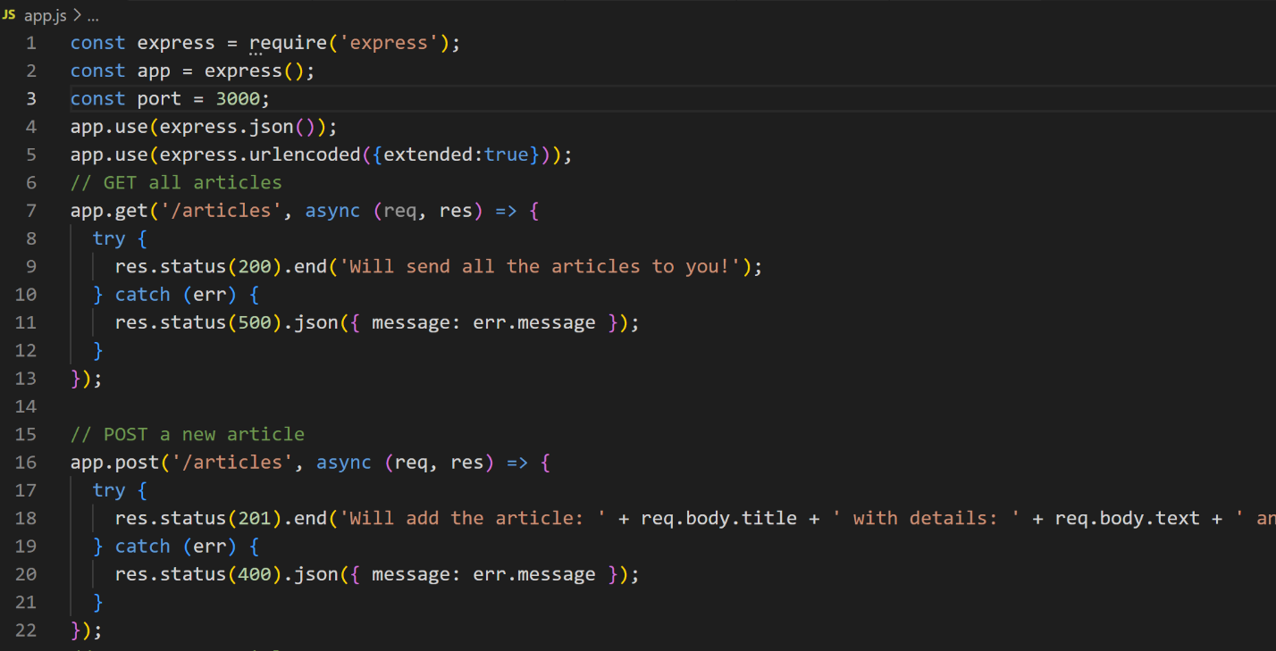

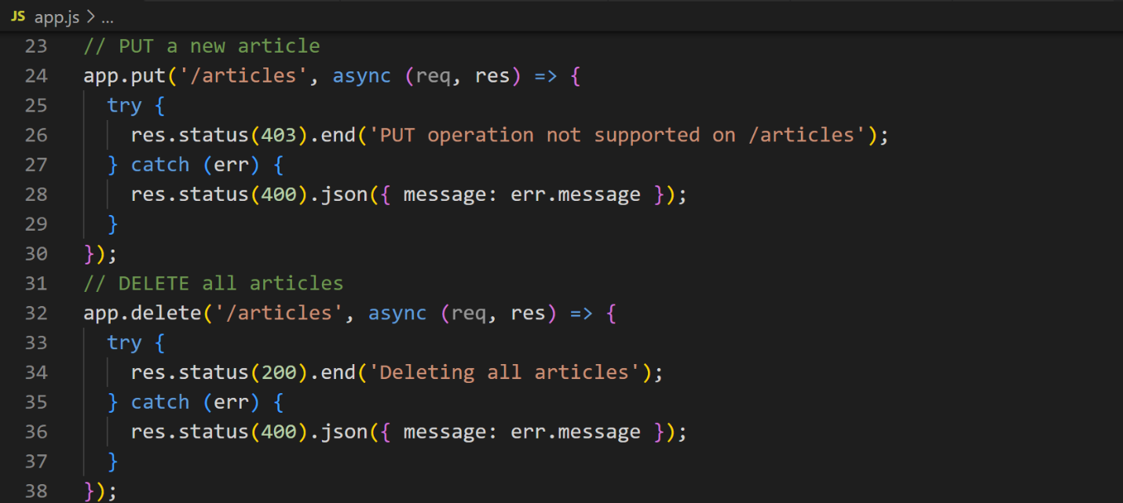

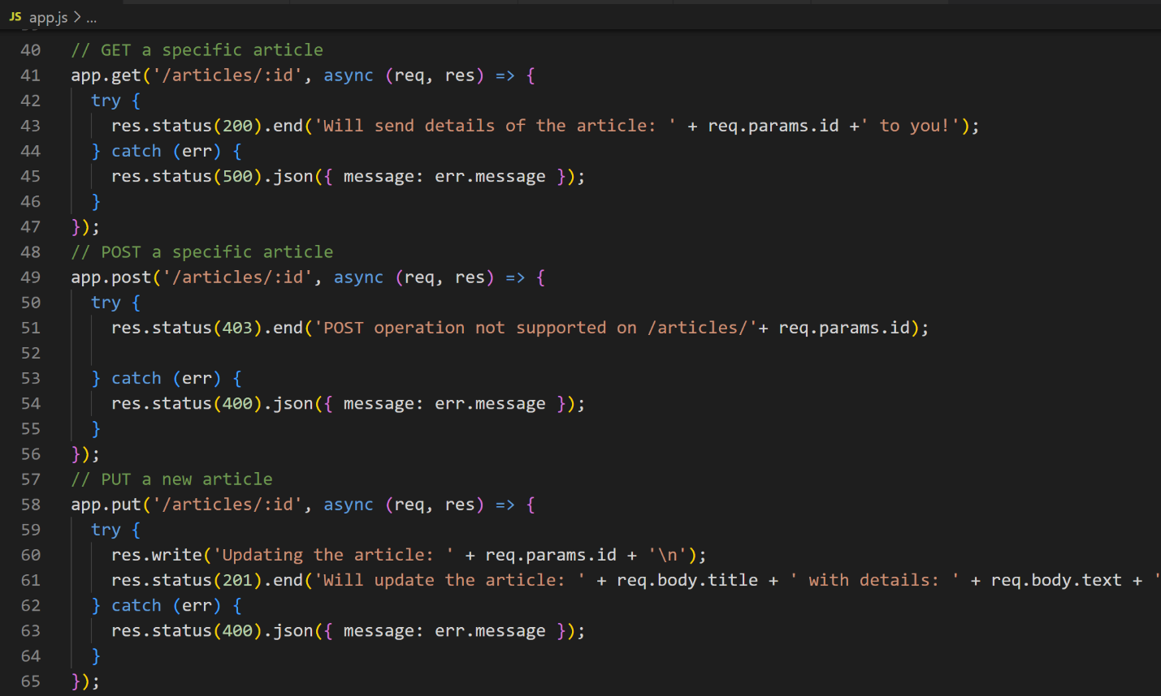
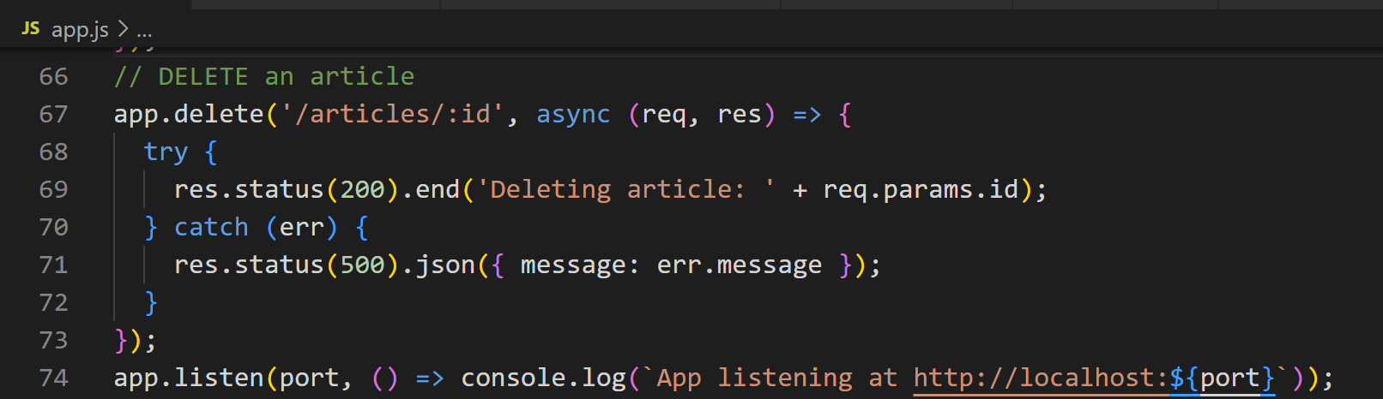

Exercise 2: Do CRUD with router
- Create node-express-CRUD app
- In the main application file (app.js), add the following code
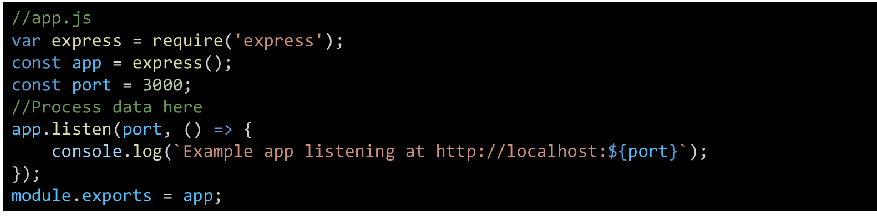
- Start the server by running the node app.js command
- Define JSON data by creating an articles.js file with the content below:
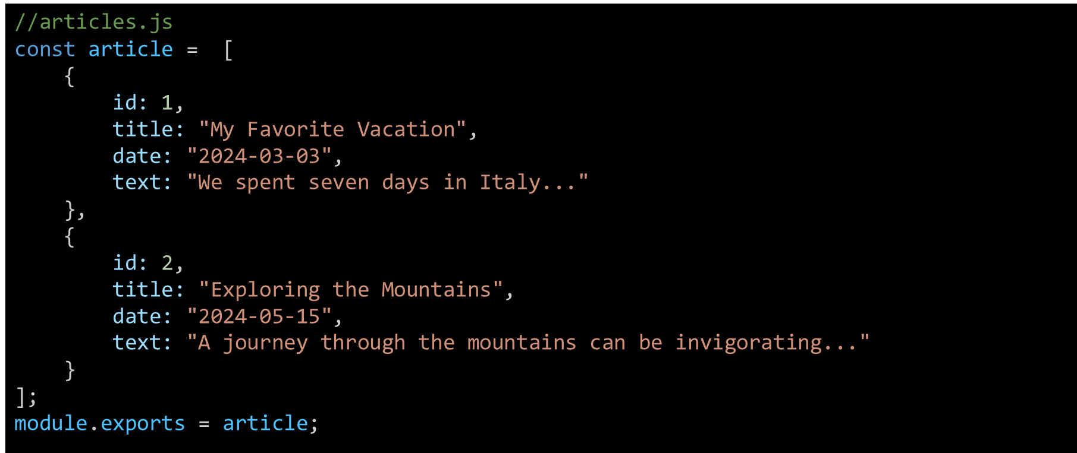
- Import data from articles.js
- Create a route to return JSON data
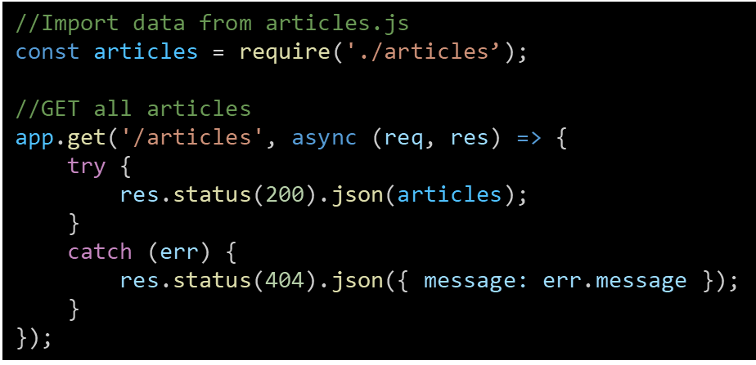
- Route to return a post based on ID
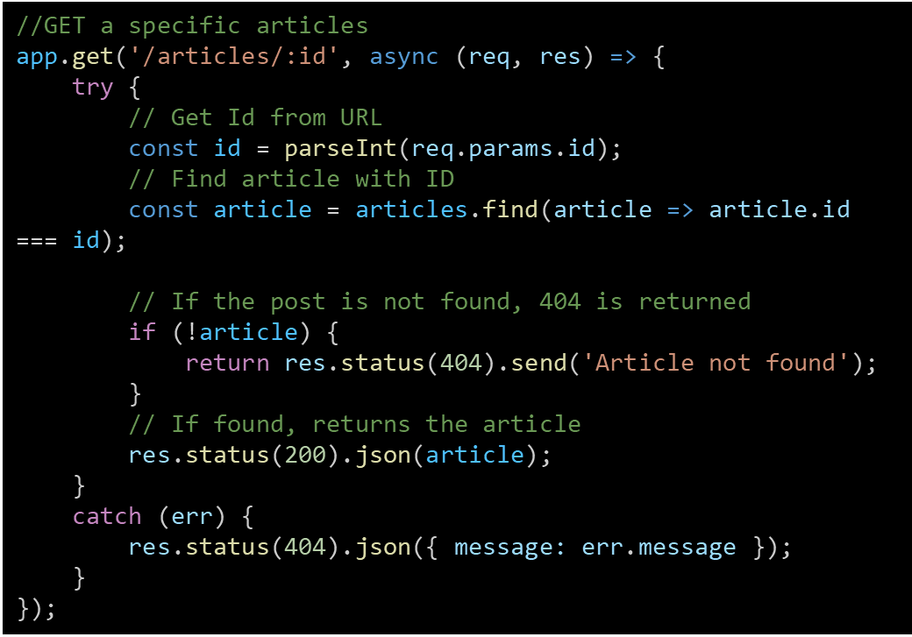
- To extend the API you are building with Express by adding POST, PUT, and DELETE methods, you need to implement processing logic for each method accordingly.
- Install Middleware to Parse Request Body.
- Before you can process POST or PUT requests, you need to install middleware to parse the data sent from the client
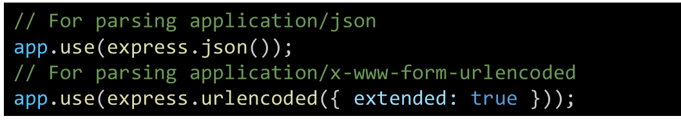
- Add a new post (POST)
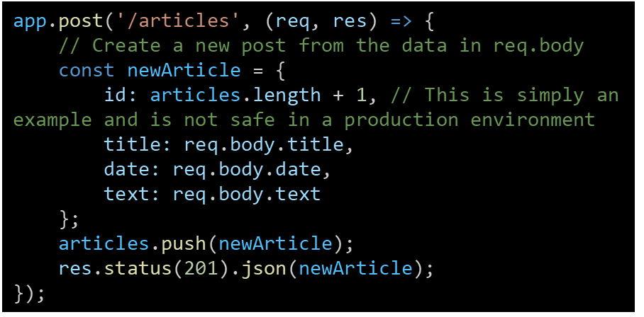
- Update a post (PUT)
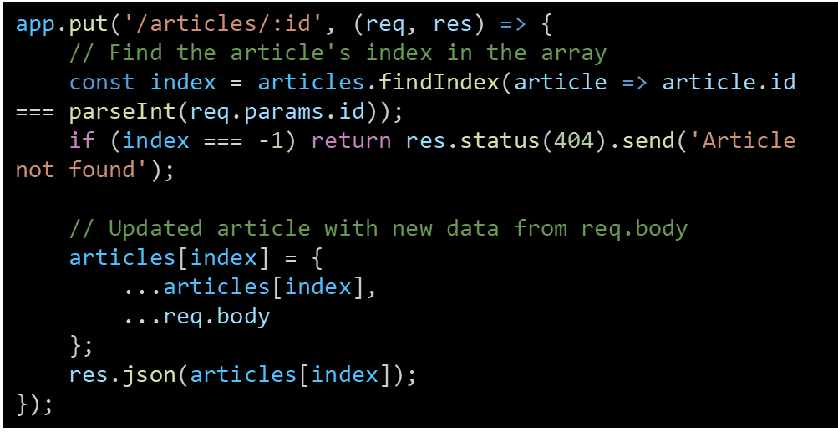
- Delete a post (DELETE)
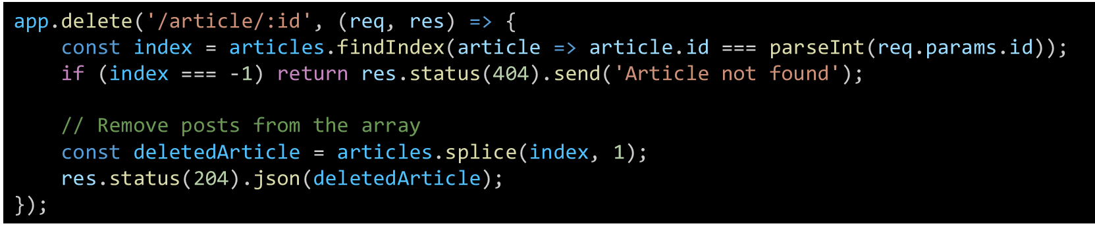
- Test with Postman
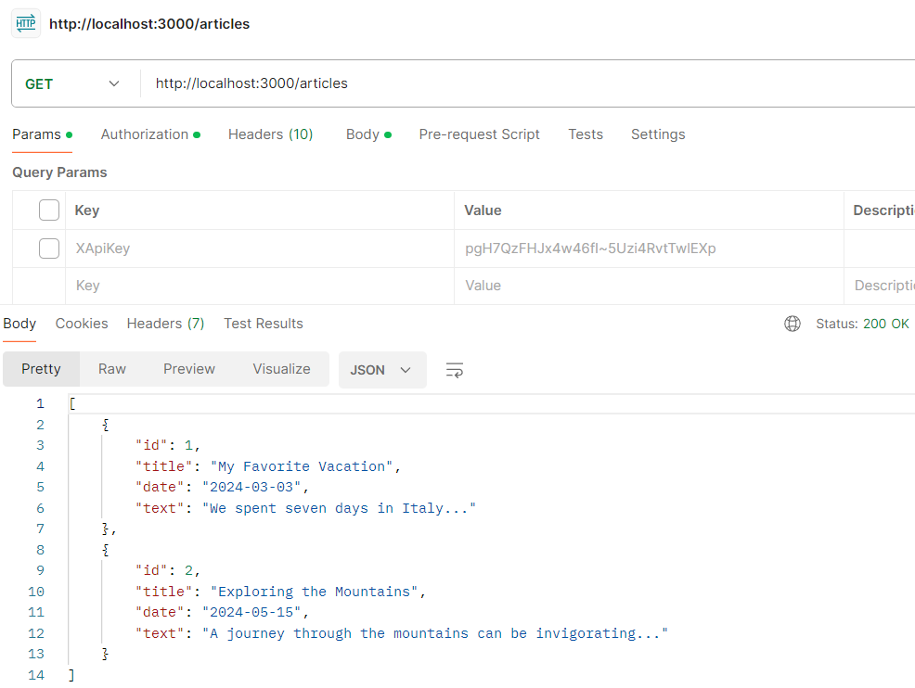

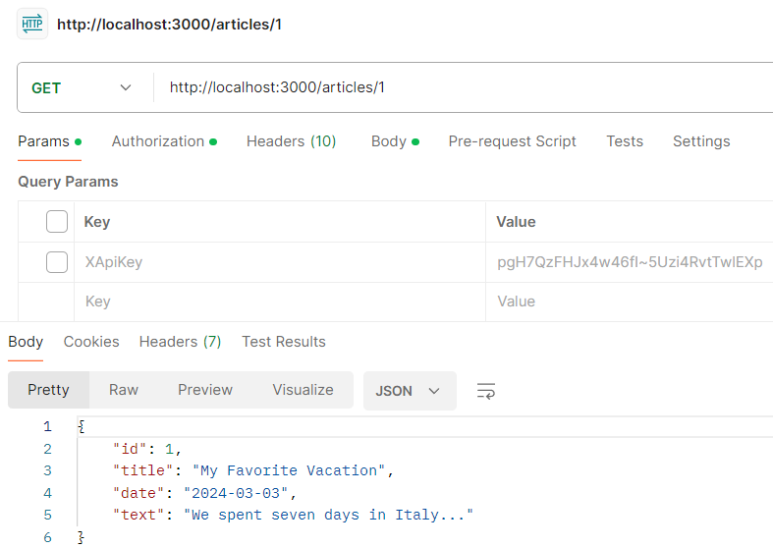

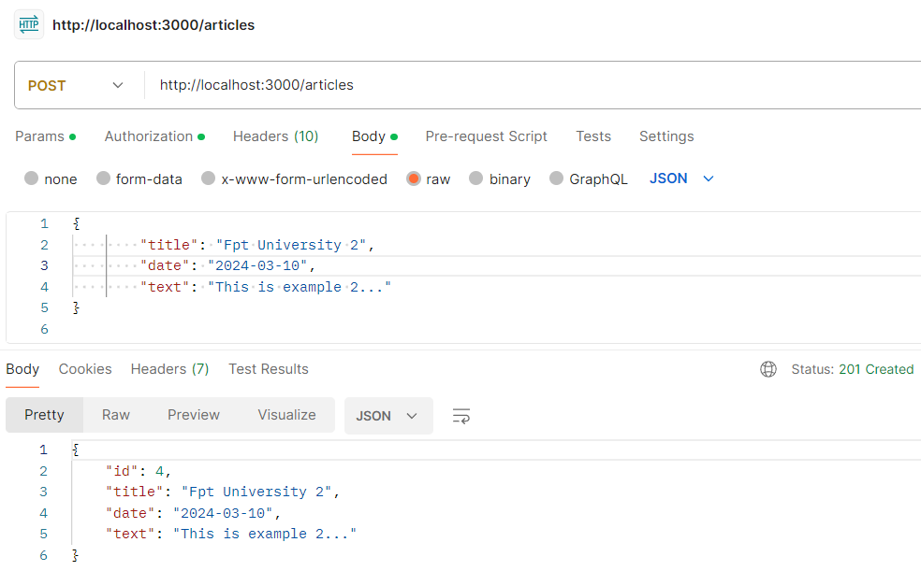

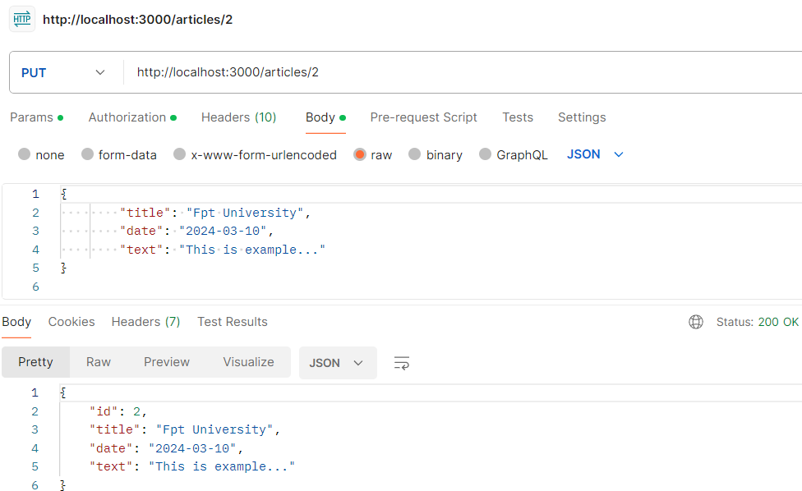

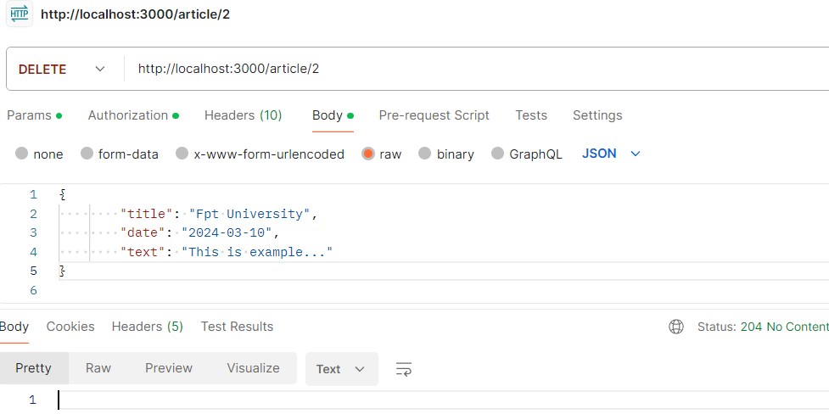

Exercise 3: From videos in db.json file, you’ll create all router for a subset of your application (GET/POST/PUT/DELETE)
- Using node-express app
- Create all router for a subset of your application (GET/POST/PUT/DELETE) in app.js file

Conclusion
This exercise aims to deepen your understanding of how to build a simple router in NodeJs app with Express framework.

